Saline Bottle Monitoring System

Ashrith.k#1,Nikhil.M#2,Shreshta.B#3,Sumanth.P#4,Teja Sai.Ch#5

Department of Electronics and Communication Engineering,

Vasavi College of Engineering.

***Abstract-*This paper is put forward to explain the implementation of automatic saline bottle monitoring system. Saline is given to patients whenever the patient gets dehydrated**. **In current health care measures, whenever a saline is fed to any patient, the patient needs to be continuously monitored by a nurse or any caretaker. Whenever the saline bottle gets emptied reflexive flow of blood into the saline bottle takes place. This is not only harmful to patient but also health hazardous. Hence, to avoid such situations the following system can be used which is also of low cost. This proposed system is a sophisticated method of saline diffusion by monitoring saline system remotely employing Internet of Things. This system has IR sensors which monitors the critical level of saline liquid and the motor mechanism stops the saline flow automatically after the saline bottle becomes empty. This can be used in homes and hospitals without much effort.**

***Keywords- monitoring system, saline, reflexive flow, low cost, IR sensors, motor mechanism, Internet of Things, critical level.***

I. INTRODUCTION

Technology is growing at a higher rate. Even when it comes to automation in different fields many things are getting automated. Even in medical and healthcare technological advancements are happening. But the process of giving intravenous fluid to patients is of age-old method. Saline is fed to treat dehydration and improve their health. There are some critical situations where the blood from patient flows back into the saline bottle due to the pressure difference between empty saline bottle and blood pressure of patient. This happens due to the laxity towards saline completion. Such manual saline monitoring is both time consuming as well as health risk. Many times, manual saline monitoring does not work well or fails because of certain disadvantages like unavailability of doctors/nurses/caretakers. So, the mechanism being discussed here prevents these abnormal situations.

The system proposed is IoT based automatic alerting system and it prevents the reverse flow of saline when it gets completed. To know the level of saline IR sensors are used as level sensors. A critical level is pre assumed. There will be change in output voltage of IR sensor whenever there is a change in intravenous fluid. The information is passed to WiFi module NodeMCU. From this module the information is forwarded to the mobile phone. The reverse flow is prevented using a motor mechanism. The supremacy of this system is a single person can monitor number of saline bottles using a single device (smart phone). Also, the risk of hazardous situations of patients are greatly minimized. This can be used in hospitals, healthcare centres and even at home.

II. OBJECTIVES

1) To provide convenient, reliable and effortless saline monitoring system.

2) To overcome or avoid the harmful situations of patient’s health owing to negligence towards saline completion.

3) To make the saline monitoring automatic and to inform the concerned person like doctor/nurse.

4) To prevent the reflexive flow of blood into the saline bottle after completions of saline.

III. LITERATURE SURVEY

*Existing System*

The existing arrangement of the saline flow system is based on the number of drops that are required for the patient. There are 2 push buttons which will rotate the stepper motor clockwise or anti-clockwise direction, one for increasing the number of drops and the other for decreasing the number of drops. The arduino is uploaded with the source code where, if once the push button is operated, 1 drop per sec if twice, 2 drops per second the saline flows. This continues up to 4 drops per second on operating the push buttons. If there should be any decrease in the flow of the saline, then the second push button is operated. The drops per second flow are displayed on the LCD. Once the saline bottle tends to become empty, the user can operate the pushbuttons clockwise for 4 times and stop the saline flow which will also stop the reverse flow of blood.

*Proposed System*

In the previous system, it was seen that there is no automatic control of the flow rate using a smart phone. The proposed IoT based indicating device acts as an assist to nurses and doctors in monitoring the patients. An effective idea is proposed to alert the doctor or nurse when the fluid level of the saline bottle is beyond the threshold limit and automatically stops the flow when the saline level is reached its minimum level. The prior objective of the proposed system developed is hassle free human dependence for automatic monitoring of the saline level. The proposed system has Infrared sensors for determining whether liquid has reached a normal level or at a critical level. By interfacing the Wi-Fi module i.e., nodeMCU and mobile application notification is sent.

IV. SPECIFICATIONS OF SYSTEM COMPONENTS

1. *IR Sensors*

An infrared (IR) sensor is an electronic device that measures and detects infrared radiation in its surrounding environment. There are two types of infrared sensors: active and passive. In our system we have used active infrared sensor. Active infrared sensors both emit and detect infrared radiation. This IR sensor module consists of one LED emitter and photo diode receiver with digital output. This system has two IR sensors to measure the level of saline. So, it is used as proximity sensor which shows a change in output voltage whenever there is a change in level of saline at the altitude at which sensor is fixed to saline bottle.

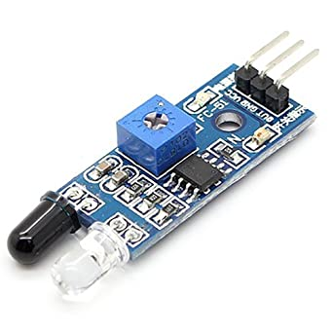

*Fig. 1 Infrared sensor*

1. *NodeMCU*

NodeMCU microcontroller is an open source microcontroller firmware which helps to build IoT products such as digital devices and interactive objects that can sense and control objects in the physical world. The NodeMCU ESP8266 micro-controller will be used as processing and programming unit for sending instructions to the servo motor and mobile application.

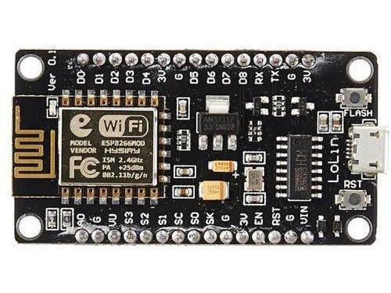

*Fig. 2 NodeMCU a WiFi module*

1. *Servo Motor*

A servo motor is a simple DC motor controlled for specific angular rotation with the help of additional servo mechanism. The speed of rotation can be controlled and we can turn it on and off. The servo motor which we used here is MG995. This servo can rotate from 0 degree to 360 degree (approximately). This servo is employed here to cease the reverse flow.

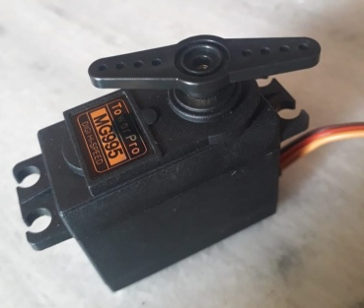

*Fig. 3 MG995 a servo motor*

1. *Clamp*

Clamp is used to constrict or press two or more things to hold them firmly. Two or three hose clamps and U-shaped clamps are used to hold the position of saline pipe. A kind of clamp aids for the purpose of holding servo motor and IR sensors in position.

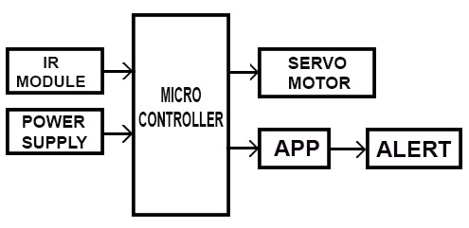Fig. 4 Block diagram of the proposed system.

1. *Mobile Application*

We have used a mobile application in order to send notifications to doctor/nurse/caretaker mobile phone. The notifications regarding all the patients of the ward are shown in a single window which makes it easy for doctor/nurse.

Even web server can also be used for notifications.

1. *Power Supply Unit*

Supplies power to the components of the system. This can be converting Ac into small amount of DC or using portable discharge batteries.

1. *Arduino IDE*

Arduino IDE is an open source software that is mainly used for writing and compiling the code in the required platform such as arduino or nodeMCU. The required programming for indicating saline level and initiating servo to control reverse flow of blood is done here and dumped into nodeMCU using this. We have used the latest version of Arduino IDE i.e., version 1.8.10

V. WORKING/METHODOLOGY:

The entire function of the module is broadly categorized into 3 parts.

1. To fetch the saline level status from the IR sensor

2. To alert the caretakers through an app

3. To stop the reverse flow of blood.

The proposed system is implemented using the NodeMCU ESP8266 WiFi module to receive data from sensors and alert the caretakers. Infrared Sensors are employed to the side of the saline bottle. One at the critical level altitude other at the mouth of the bottle. The second sensor is used to indicate the completion of saline in the bottle. The sensors send digital data to the NodeMCU which in turn sends the information to caretakers, nurses who use either web browser or the developed application

The IR sensor here has both transmitter and receiver on the same sensor module. With the power supply on, the transmitter transmits the radiation continuously. The saline in the bottle absorbs this radiation, so the receiver will not detect any radiation, so it gives a LOW digital logic to NodeMCU. So, when the saline level crosses the critical level, the radiation from the first sensor gets reflected from another side of the bottle, for which the sensor gives a HIGH digital logic to NodeMCU. Similarly, when the saline bottle becomes empty, the second sensor receives reflected radiation, for which it gives a HIGH digital logic.

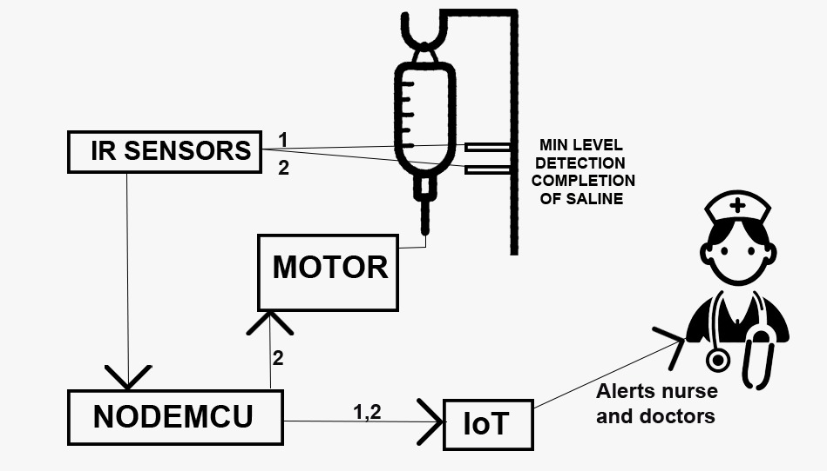*Fig. 5 Picture depicting the working of the system.*

We can infer that when both sensors give digital logic LOW, it indicates the saline level is not under a critical level. When only the first sensor gives digital logic HIGH, it indicates saline level is about to empty, i.e., it crossed the critical level. When both sensors give digital logic HIGH, it indicates the saline bottle is empty. This information is continuously received by NodeMCU.

To transmit the information/ status about the saline level, IoT is used here. Since the ESP8266 has a built-in WiFi module, it is connected to the local access point. This assigns a particular IP address to that NodeMCU. This remains unchanged until the NodeMCU connects to another access point. The HTTP protocol is implemented here. It works as a request/response protocol. HTTP client helps to send HTTP requests and receiving HTTP responses from the HTTP server. The developed app(an HTTP client) requests the NodeMCU(an HTTP server) for the information. Whenever the caretaker requires the status he/she just press buttons corresponding to bed allocated. This makes the app to request the server NodeMCU. Though the NodeMCU receives data from sensors continuously, it only transfers information only when a request is made. A caretaker can use either a web browser or application developed to check the status.

|  |  |  |  |  |
| --- | --- | --- | --- | --- |
| **Saline Level** | **IR Sensor 1** | **IR Sensor 2** | **Servo Motor** | **Mobile Notification** |
| Above critical level | LOW/OFF | LOW/OFF | OFF | Saline level of B1 NOT REACHED critical level. |
| Below critical level | HIGH/ON | LOW/OFF | OFF | Saline level in B1 CROSSED critical level |
| Saline bottle emptied | HIGH/ON | HIGH/ON | ON (blade rotates120 degree and stops) | Saline level of B1 is EMPTY. Reverse flow is STOPPED |

*TABLE 1 Level of Saline in Saline Bottle and Corresponding Notification that will be Sent.*

When the saline level drops to zero i.e., the bottle becomes empty, the pressure difference developed makes the blood flow into the bottle. To avoid this a servo motor is used. It is fixed on a rectangular metal sheet that is clamped in the middle of the saline stand. The saline pipe is fixed to the sheet right under the blade of the motor. When NodeMCU detects the status as an empty bottle, it turns on the motor. The blade turns about a previously fixed angle and squeezes the pipe against the sheet, which avoids the reverse flow of blood. In this way, the automatic system works without human intervention.

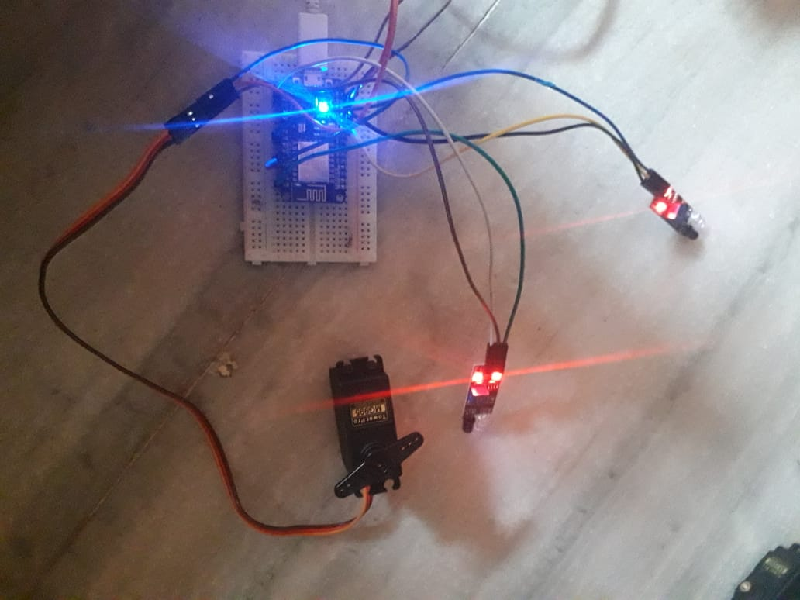*Fig. 6 Picture showing the connections of the system.*

*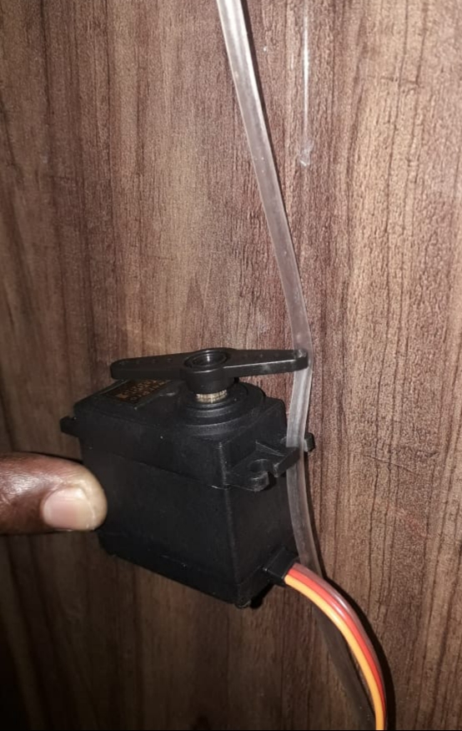Fig. 7 Servo motor blocking the reverse flow*

VI. RESULT

An android application is developed in order to alert about the saline levels without human requirement. This app is designed in such a way that it sends information to the doctors and nurses according to the data sent by IRs that are fixed adjacent to saline bottle. This module is efficient in terms of alerting, operating, less complex with least hardware involved. In order to design the hardware usage of simple tools made the equipment easy to handle and less in weight. The employed servo motor which is clamped to the stand successfully stops the reverse flow of the blood, which occurs after fluid completion due to pressure difference. This works with less hardware involved which makes it more reliable.

The proposed system is connected as shown in fig.6. Whenever the saline in the saline bottle is completed the servo motor is running and is successfully able to stop the reverse flow as shown in fig.7. Also, corresponding notification is sent to the mobile based on the saline level in saline bottle as shown in table 1.The notification can be seen in either web browser s shown in fig.8 or in a mobile application as shown in fig. 9.Another feature of this system is multiple patient’s saline level can be monitored in a single window as shown in fig.13.The following are the results obtained .

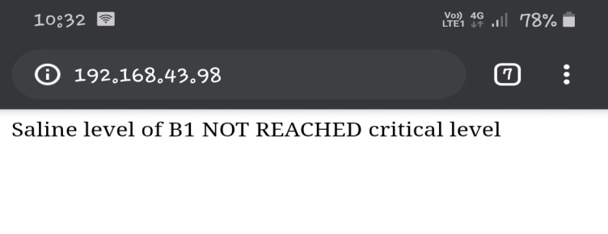*Fig. 8 Web server notifying that bed1(bottle-1) not reached critical level*

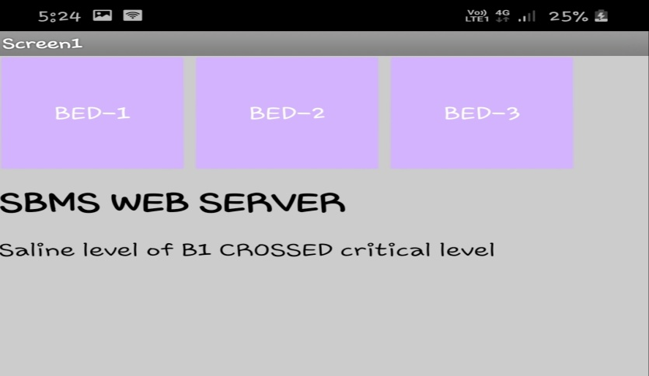*Fig. 9 Mobile application notifying that bottle 1 crossed critical level.*

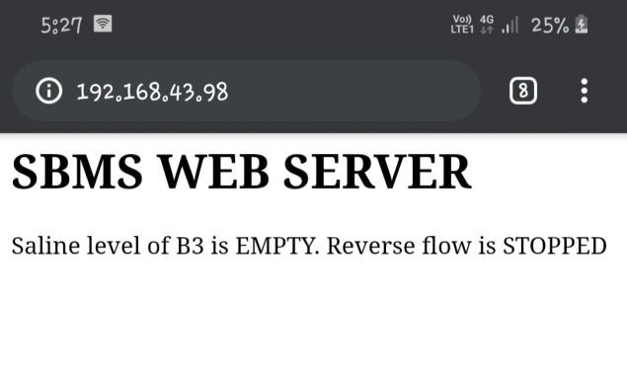

*Fig. 10 Web server noitying that sa;ine level in bed-3(bottle-3) is empty and stooping the reverse flow .*

*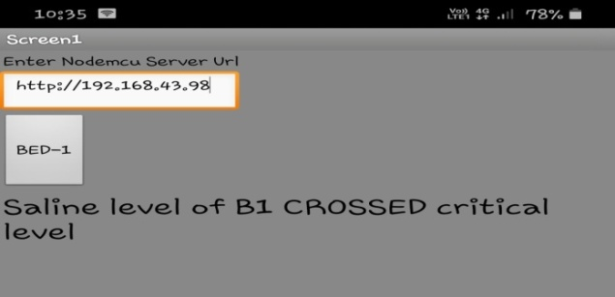Fig. 11 Webserver indicating the saline level of B1 .*

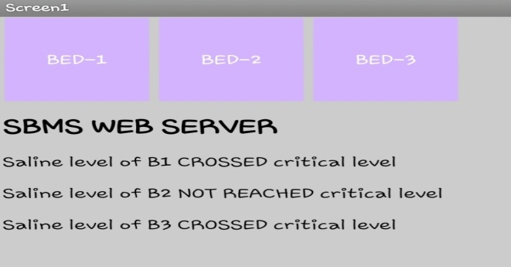*Fig. 12 Mobile application showing the condition of all three saline bottles in a single window.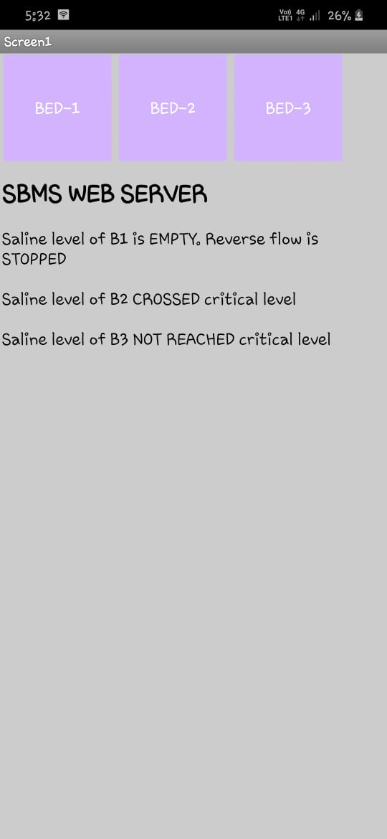 Fig. 13 Mobile application showing saline levels in all three saline bottles on a single window*

VII. DISCUSSION:

*Limitations:*

1.If any light falls directly on to the Infrared sensors there may be variation in results compared to those that are actually to be obtained.

2. If the present system is used for some other intravenous fluids (which may be coloured) then deviation in results are observed.

*Recommendations:*

1. Portable

2. Developing the module with usage of even simpler tools.

VIII. CONCLUSION:

As the world is growing enormously in terms of technology in all fields especially in medical field, this system is an aid by engineering to medicine. In this paper we have shown the functionality of the proposed system. The module developed met the objectives we set. It’s a convenient, reliable and effortless saline monitoring system. It avoids the harmful situations of patient’s health owing to negligence towards saline completion. The system is fully automatic in terms of monitoring the saline status and can handle the hazardous blood reverse flow situation. The implementation of alert system became easy with IoT, which made this system more flexible when compared to existing methods.

IX. Acknowledgment:

We would like to thank Mr. V. Krishna Mohansir and Mrs. A. Sri Laxmi madam for consistent guidance, encouraging and sympathetic attitude throughout the total work for the project. The guidelines and suggestions that are addressed by sir were thought provoking and innovative which has resulted significant improvements in the project.

X.REFERENCES:

[1]. Mansi G. Chidgopkar, Aruna P. Phatale “Automatic And Low Cost Saline Level Monitoring System Using Wireless Bluetooth” International Journal of Research in Engineering and Technology; Volume:04 Issue:09 Page No. 274-276 September-2015 .

[2]. [Dr N. Venkataram](https://www.researchgate.net/scientific-contributions/2142501922_Dr_NVenkataram), [P Vijay Varma](https://www.researchgate.net/scientific-contributions/2142485868_P_Vijay_varma), [B Naga Malleswari](https://www.researchgate.net/scientific-contributions/2142497810_B_Naga_Malleswari) “Smart Saline Level Monitoring System using IOT” International Journal of Engineering and Technology March 2018.

[3]. R.Priyadharshini, S.Mithuna, U.Vasanth Kumar, S.Kalpana Devi, Dr. N.Suthanthira Vanitha.N “Automatic Intravenous Fluid Level Indication System for Hospitals” International Journal for Research in Applied Science & Engineering Technology (IJRASET) Volume 3 Issue VIII, August 2015 Page No. 427-432 .

*For HTTP server using NodeMCU:*

[4] <https://www.electronicwings.com/nodemcu/http-server-on-nodemcu-with-arduino-ide>

*For multiple clients:*

[5] <https://arduino.stackexchange.com/questions/53878/to-send-data-perpetually-from-multiple-clients-to-a-server-using-nodemcu>

*A beginner guide to establish Wi-Fi connection using ESP8266:*

[6] <https://tttapa.github.io/ESP8266/Chap07%20-%20Wi-Fi%20Connections.html>

*For configuring NodeMCU in different modes:*

[7] <http://onlineshouter.com/use-esp8266-wifi-modes-station-access-point/>

[8] <https://www.instructables.com/id/Both-Mode-ESP8266-AP-and-Client-Mode/>

*A beginner guide to establish Wi-Fi connection using ESP8266:*

[9] <https://randomnerdtutorials.com/esp8266-controlled-with-android-app-mit-app-inventor/>

[10]<https://github.com/mit-cml/appinventor-sources>

.